**Glen Canyon Dam releases to promote bugs and generate hydropower**

**Moazzam Ali Rind1; David E. Rosenberg2; and John C. Schmidt3**

1 Department of Civil and Environmental Engineering, Utah State University, Old Main Hill, Logan, UT 84322, USA; Phone: (435) 774-6429: email: [moazzam.rind@usu.edu](mailto:moazzam.rind@usu.edu)

2 Department of Civil and Environmental Engineering, Utah State University, Old Main Hill, Logan, UT 84322-4110, USA; Phone: (435) 797-8689: email: [david.rosenberg@usu.edu](mailto:david.rosenberg@usu.edu).

3 Department of Watershed Sciences, Utah State University, Old Main Hill, Logan, UT 84322-4110, USA; Phone: (435) 797-1791: email: [jack.schmidt@usu.edu](mailto:jack.schmidt@usu.edu).

**ABSTRACT**

Stoneflies, Mayflies, Caddisflies, and Midges (affectionately “bugs”) are food for the endangered native and non-native fishes of the Colorado River between Glen Canyon dam and Lake Mead, Nevada. These bugs lay their eggs at dusk on rocks and other strata just below the water surface and require at least 48 hours of inundation to hatch. Hydropeaking operations--the daily fluctuations in dam releases by up to 8000 cfs to generate more energy during afternoons when energy demand and prices are high--desiccates bug eggs. The U.S. Geological Survey’s Grand Canyon Monitoring and Research Center (GCMRC) and Western Area Power Authority (WAPA) are still evaluating the effects of summer 2018 experimental steady weekend releases to encourage bug egg hatching. Here we share results from a non-linear multi-objective optimization model that recommends Glen Canyon dam releases to maximize energy revenues and minimize a bug objective that is quantified as the standard deviation of releases. The model runs for one month with two sub-daily timesteps and is subject to daily release limits, maximum energy generation, storage limits, and an exogenously specified monthly release volume. We used the constraint method to identify the tradeoff between the energy generation and bug objectives. We tested scenarios that vary the month of the year, monthly flow volume, number of consecutive days of bug flows, and the steady bug flow release value. Preliminary results show: 1) Increasing the monthly release volume simultaneously improves the bug and energy generation objectives. 2) Increasing the number of steady bug flow days from 2 to 4 increases the standard deviation of flows; standard deviation of flows is not a good metric for bugs. This is a working document and materials will be updated over time based on work with GCMRC, WAPA, and others.

**INTRODUCTION**

Aquatic eco-system is one of the major components of the environmental life cycle. It is home to unique species, and provides food, pleasure, and sustainability to the related systems including humans. However, due to uncertainty in inflows and growing water demand (municipal, industrial, agricultural, hydropower etc.), the majority of Earth’s rivers are now dammed (Nilsson et al. 2005). This anthropogenic development has drastically altered the ecosystems (Carpenter et al. 2011), and the natural flow regimes are engineered to meet the societal needs (Poff et al. 2007). The upshot of those hydrologic modifications on downstream ecology is yet to be quantified and mitigated (Kareiva et al. 2000, Dugan et al. 2010).

Elsewhere, water resources are managed for multiple and competing uses, such as water supply, hydropower, flood control, recreation and environmental protection (Null and Lund, 2012). In particular, the world’s largest dams, including the Three Gorges Dam on the Yangtze River in China, the Itaipu Dam on the Paraná River in Brazil and Paraguay, and the Hoover Dam on the Colorado River in the United States are built and operated as storages of water supply and an immense sources of hydropower generation (World Commission on Dams, 2000). Until recently, the impacts of these artificial storages on downstream eco-system has been ignored. There is growing interest and wide recognition of the problem; with environmental objectives put before the hydropower (Richter, 2014; Pegram et al., 2013; Hart, 2015). Some studies also claim the precedence of rivers increasingly managed to support aquatic ecosystems and fisheries, in addition to traditional human water demands (Null and Lund, 2012). Still, for easy implementation, the concept of environmental flows needs further elaboration regarding measurable ecological objectives and methods to achieve those objectives (Alafifi and Rosenberg, 2016).

In the modeling world, the environmental flow operations are normally mimicked by simulation or optimization methods (Adams et al., 2017). For the reason, numerous studies have been carried out and number of methods have been developed to determine environmental flow requirements (Tharme, 2003; Arthington, 2012). On the contrary, translating that acquired ecological knowledge into operational paradigms is yet another challenging task (Harman and Stewardson, 2005). Hence, there is an urgency for water managers to find ways that can trade off and balance the competing environmental watering objectives (Acreman et al., 2014; Richter, 2014; Poff et al., 2015).

In total, the Grand Canyon is home to five different eco-systems (National park service, 2011-12). However, the presented study will only focus on the aquatic eco-system and related species. Aquatic eco-system in the Grand Canyon is managed by releases from the Glen Canyon Dam- second highest concrete-arch dam in the United States with storage capacity of 26.2 million acre-ft. Besides, the Glen Canyon Powerplant is huge source of hydropower generation with an annual total of five billion kilowatt-hours. Which is distributed by the Western Area Power Administration (WAPA) to Wyoming, Utah, Colorado, New Mexico, Arizona, Nevada, and Nebraska (USBR, 2019).

One of the upshots from hydropower dams, to meet daily energy demand variation, is hourly timescale fluctuation in release amount known as load following or hydropeaking (Kennedy et al., 2016). Under hydropeaking, the river flows are increased during the daytime and decreased at night; chasing the energy demand (Førsund, 2015). In some cases, the required variation in flow can be substantial, and the release value varies by factor of 10 or more within a day (Moog, 1993, Topping et al., 2003). These changing releases stress rivers, including water temperature, flow velocity, sediment transport, and water depth (Poff et al. 2007, Schmidt and Wilcock 2008, Olden and Naiman 2010). These stressors adversely affect the aquatic life, and often extirpate organisms that rely on nearshore environments during one or more stages of life cycle (Kennedy et al., 2016).

For example, aquatic insects (bugs) are amongst worst affectees of hydropeaking phenomenon. Bugs lay their eggs at dusk time, when the water level is fairly high, on the river edges. During nighttime, due to hydropeaking, the water level drops, the river width shrinks and the river edges dry out. When the river edges dry out, the bug eggs desiccate, and the population of bugs drops. These bugs are the primary food for myriad species of fish, birds, bats, and other wildlife living in and along the river (Nakano and Murakami 2001, Baxter et al. 2005). Kennedy et al., 2016 found that insect diversity is strongly and negatively related to the degree of hydropeaking index in 16 rivers below 16 dams across the western United States.

Kennedy et al., 2016 also found that Glen Canyon Dam has the lowest invertebrate richness in comparison to other dams. There are reports blaming cold releases from dams responsible for invertebrate community assembly in tailwaters (Olden and Naiman 2010), including for the Colorado River ecosystem downstream of the Glen Canyon Dam (Stevens et al. 1997). However, Kennedy et al., 2016 modifies that notion by presenting a strong inverse relationship between hydropeaking index and invertebrate diversity.

Kennedy et al (2016) further suggested an innovative solution to the problem by recommending Glen Canyon Dam release stable low flows on weekends. Since electricity demands are low on weekends (Førsund 2015), weekend hydropower revenue losses will be small (USBR, 2016). The stable low flow conditions will allow eggs to incubate for 48 hours and hatch. Eggs laid on weekends remained wetted and never subject to desiccation prior to hatching, which typically occurs after days to weeks of incubation (Merritt et al., 2008, Statzner and Beche, 2010). Thus, the suggested environmental flows will substantially help aquatic-insect egg laying and rearing life stages.

To test the hypothesis of steady low weekend flows put forward by Kennedy et al., 2016, the first bug flow experiment was conducted between May and August, 2018 (GCDAMP, 2019). The experiment was included in the Preferred Alternative of the long term experimental and monitoring program ([LTEMP DEIS](http://gcdamp.com/index.php?title=Long-term_Experimental_and_Management_Plan_(LTEMP))) and has been repeated in 2019. Several researchers are trying to quantify the impacts of bug flow experiment. Ploussard & Veselka, 2019 explore the financial implication caused by the experiment. Although the study has quantified the financial difference due to hydropower generation variability from hydropeaking but, no one has shown the tradeoffs between hydropeaking index and hydropower revenue generation.

This study will calculate the tradeoffs using optimization model developed in general algebraic modeling system (GAMS). If low steady flows are favorable for bugs population, the developed model has capability to devise dam releases (decision variable) corresponding to maximization of hydropower revenue and minimization of hydropeaking index. The model runs for one month with two sub-daily timesteps subject to daily release limits, maximum energy generation, storage limits, and an exogenously specified monthly release volume. To deal with multiple objectives problem, the constraint method was used to identify the tradeoff between the energy generation and bug objectives. The model shows how the bug-hydropower revenue tradeoff changes for scenarios that vary month of the year, monthly flow volume, number of consecutive days of bug flows, and the steady bug flow release value. .

**METHODS**

A multi-objective optimization model for Glen Canyon Dam, Arizona was setup in GAMS; having daily inflow volume, estimated daily evaporation, and initial reservoir storage (datasets were acquired from USBR website: <https://www.usbr.gov/rsvrWater/HistoricalApp.html>). Also, for simulation purpose, 15 mins flow data observed at Lees ferry was acquired from GCMRC website (<https://www.gcmrc.gov/discharge_qw_sediment/station/GCDAMP/09380000>) and feed in the model. For energy comparison, the observed daily megawatt hour (MWh) values (from USBR website) was compared with the modeled daily MWh values. The hourly power (MWh) prices used in the model were provided by WAPA official.

The model has two objectives:

*Minimize hydropeaking index (Bugs Objective)*

ObjectiveVal(f*HydropeakingIndex*)= Obj_dir(fHydropeakingIndex) ×

(standarddev(d)/Avgrelease(d)); ∀ d ∈ D

*Maximize Revenue from energy generation (Hydropower Objective)*

ObjectiveVal(f EnergyRevenue)= Obj_dir(f EnergyRevenue) × ×

EnergyRate(p); ∀ d ∈ D, p ∈ P

*Where: Obj_dir is controlling the direction of the equation i.e. whether to maximize or minimize the objective.*

The model has opportunity to devise releases and was subjected to number of constraints, including reservoir mass balance, storage limits, minimum and maximum release limits, ramp up and ramp down limits, maximum energy generation, and total monthly release volume.

Within the developed modeling code, two sub models were embedded and executed simultaneously. Each of the sub model has its specific importance in the overall framework and were interdependent. Initially, the extreme points model (one of the sub model) was solved and the extreme values for objectives were acquired. Later, while applying constraint method, various intermediate hydropeaking index values were between the extreme values, and each of the intermediate value was made constraint for the run. The model was solved for hydropower revenue generation value corresponding to that constraint hydropeaking index value. In total, the pareto optimal curve amongst objectives under each of the total monthly volume values was prepared (refer results sections for further details).

For validation, observed release data on hourly timestep for April and June 2018 were used to calculate hydropeaking index, energy generation, and hydropower revenue generation results (Eqs. 1 and 2). Several sub-daily timesteps of different start times and durations were tested to determine (Table 1). The use of 2 or 4 sub-daily timesteps reduces the computational burden by a factor of 12 or 6 over and hourly timestep and helps reservoir operators and stakeholders focus on key attributes of the release hydrograph.

**Table 1 Details of the scenarios tested under validation of the model**



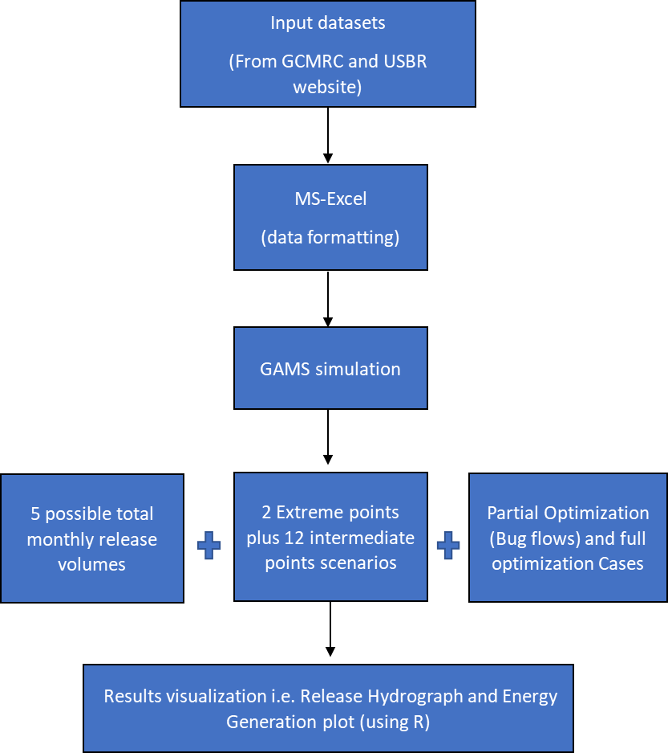Additonally, the model was run for X scenarios that test 5 monthly release values, Y durations of steady flows, and Z ----------- (Table 2 or Figure 1).

**RESULTS AND DISCUSSION**

Model Validation

For all sub-periods tested, modeled energy revenue is close to the observed revenues calculated at an hourly timestep (Tables 2 and 3).

For hydropeaking index calculation, two different approaches were considered: Monthly co-efficient of variance (CV) and daily co-efficient of variance averaged over the month. Under monthly CV approach, the model was given opportunity to calculate a single best CV value for the month benefiting both the objectives. While in the second approach, a daily co-efficient of variance value was calculated and averaged over the month. In both approaches the values found for CV were quite different (Table 2 and Table 3), however, the daily co-efficient of variance averaged over the month approach was considered for further simulation. The selection of approach was influenced by prior work by Kennedy et al., 2016.

Next was the consideration of the daily CV values and revenue generated under different scenarios (Table 2 and Table 3) to finalize the day’s division in periods, and the duration of those periods. Hourly power price provided by WAPA was also considered while setting the periods duration. Overall, scenario 3 (Table 1) was found most feasible for the analysis.

.

**Table 2 Validation results April-2018**



**Table 3 Validation results June 2018**



and 3 show the time series of observed and simulated energy generated in April and June 2018. . The modeled energy values are greater than the observed values However, the total energy generated is nearly identical across the different test periods. The reason behind this insensitivity is the same volume of release under all the scenarios.

**Error! Reference source not found.** and Figure 5 compare the observed and simulated reservoir release hydrographs. Varying the period start times modifies the high and low flow periods. The scenario with low flow from 0:00 to 8:00 and high flow from 8:00 to 0:00 fits the observed hydrograph better than other scenarios. Hence, the scenario was selected for tradeoff analysis.

**Figure 1** **Energy plot for different validation runs (April 2018)**

**Figure 2 Energy plot for different validation runs (June 2018)**

**Figure 3.** **Hydrographs for different validation runs with monthly flow of 0.75 Mill acre-feet (April 2018)**

**Figure 4 Hydrograph for different validation runs (June 2018)**

Note: observed and simulated hourly runs are overlapping

Note: observed and simulated hourly runs are overlapping

The tradeoff analysis shows that there are manyopportunities to improve the hydropower revenue and bug objectives (Figure ??). By moving from 2 days bug flow practice (solid line) to optimize release pattern suggested by the model without any specified constant bug flow days (dashed line) can improve both the objectives significantly. And the size of window increases as the total monthly release volume increases. The black square in Figure 6 mimics the observed release pattern of June 2018. While comparing the observed case with the min point on the optimization curve with the same total volume (sky blue dashed line below the black square) it can be safely concluded that even by having zero hydropeaking -flat constant flow throughout the month- the loss in energy revenue generation will be only half a million under the observed release volume.

Conversely, the results from the daily CV averaged over the month (Figure 7) illustrates that curves from both the scenarios (i.e. run with 2 days bug flow and optimization without bug flow) overlaps. Which means almost no window of improvement between 2 days bug flow and optimization cases. Still, comparing the observed case with the min point on modeled curves with the same total volume (sky blue line below the black square) concludes the same point that by having zero hydropeaking -flat constant flow throughout the month- the loss in energy revenue generation will be only half a million under the observed release volume. However, the presented study focuses on the daily CV averaged over the month approach.

The model has capability to produce releases and energy generated values at each of the location along the curve. For example, Figure 8 and Figure 9 presents the release hydrograph and energy plot for the middle points of both curves under the observed total monthly release volume of June 2018.

In addition, the model was simulated with increased number of bug flows days (Figure 10) as well as increased bug flow release value (Figure 11). While increasing the number of bug flow days the model becomes infeasible for greater release volumes. Hence, the infeasible outcomes were ignored in Figure 10. The reason behind the infeasibility was the constrained monthly total release volume to achieve. With the increased number of bug flow days, the model was unable to spit the required volume while keeping the other constraints. Nevertheless, it can be observed in Figure 10 that the feasible 3 and 4 days bug flow curves are also overlapping the optimization and 2 days bug flow curves. It is worth notice that increasing the number of bug flow days decreases the range of the curve. Which means with increase number of constant bug flow days, the model is left with only few possible options to choose amongst.

On the other hand, results shown in Figure 11 suggests that increasing the bug flow release values significantly cuts the hydropower revenue generation objective. In case of higher total release volumes, same limitation occurs i.e. increasing the bug flow share hijacks the model outputs and the model have only limited or no solution to the question asked with other constraints also in action.

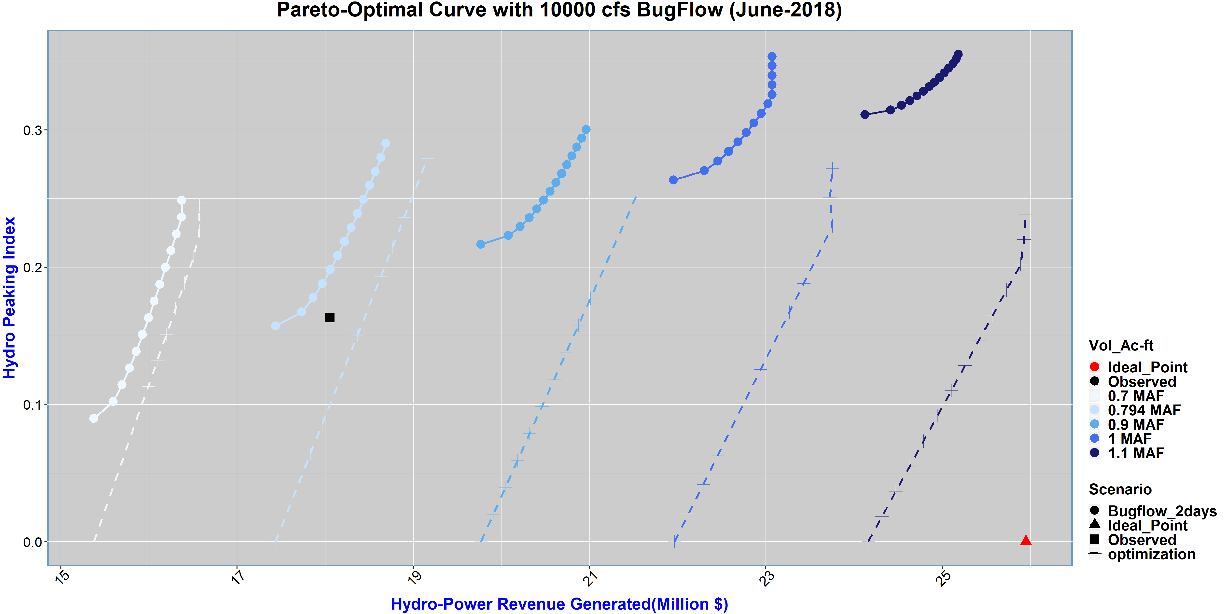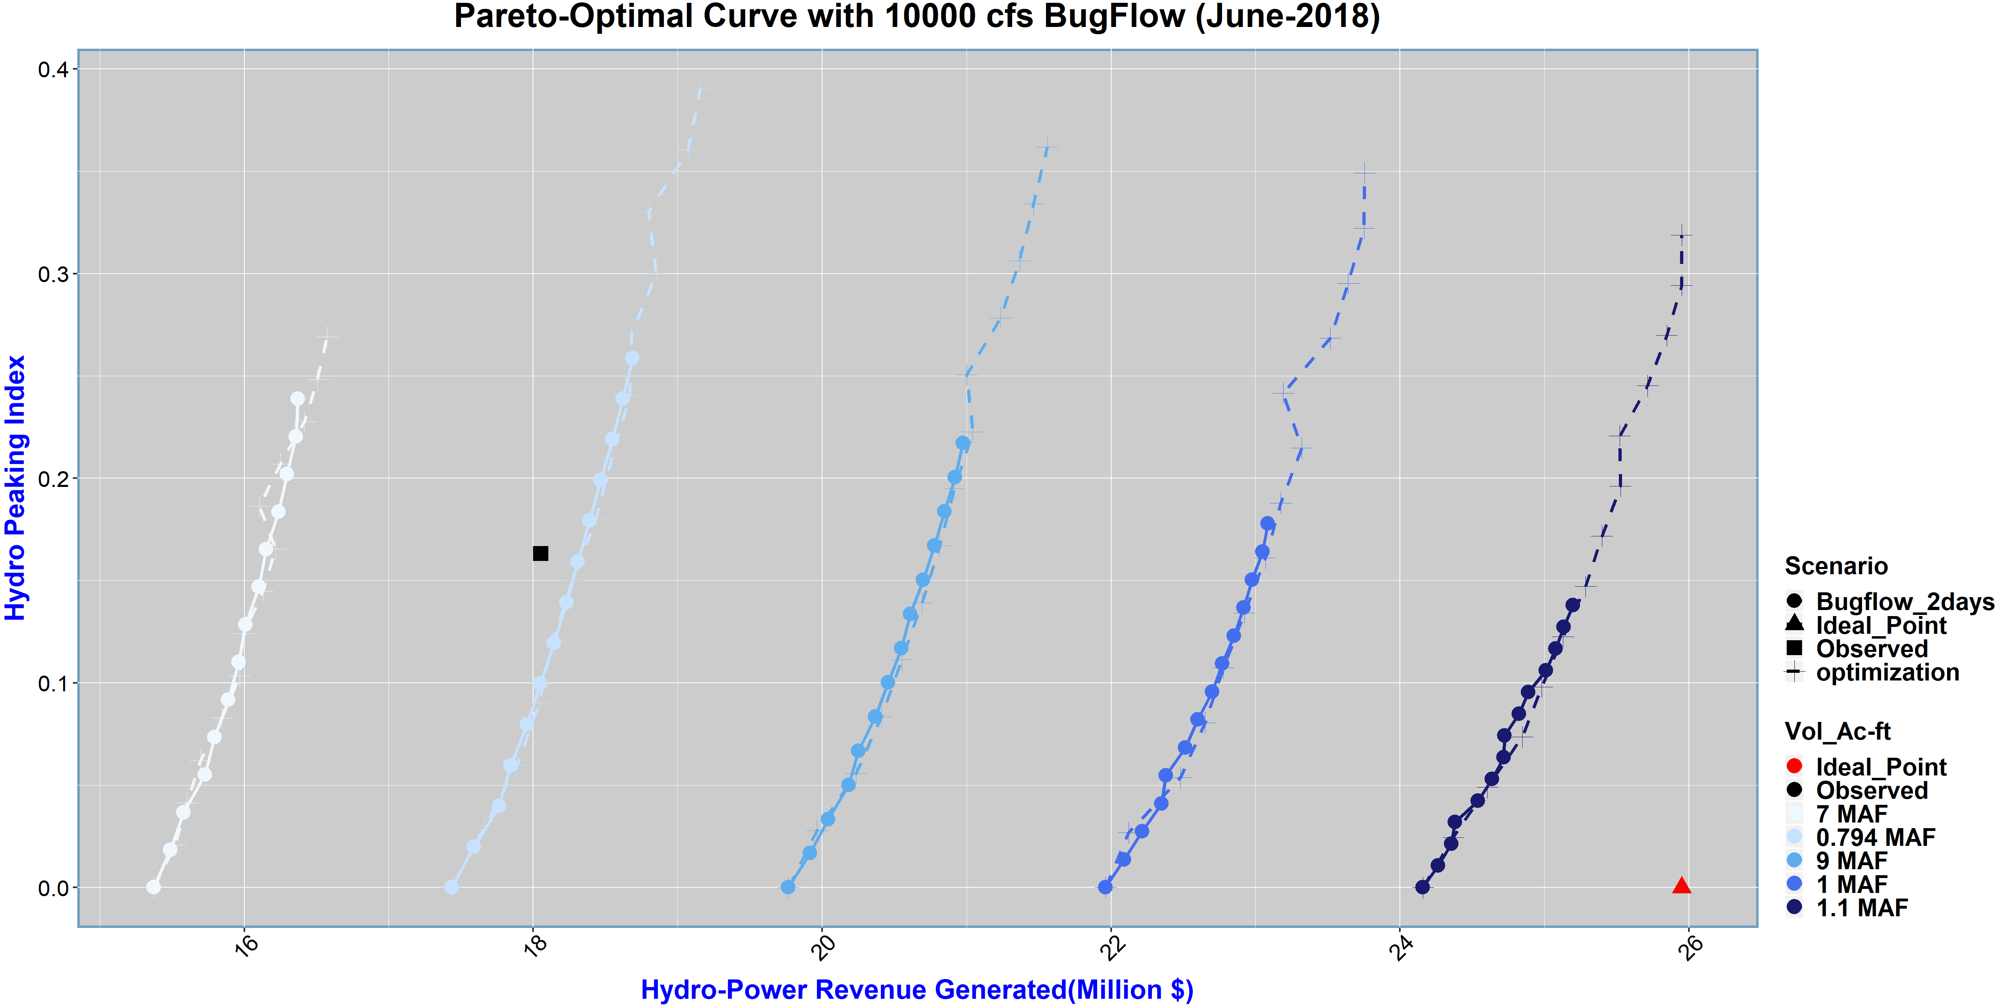

**Figure 5** **Tradeoff Curves between Hydro-power revenue generated and Hydropeaking Index under different total monthly volumes (Light to dark blue color) for June 2018. The dashed line is showing trade-off curve under full optimization case, whereas, the solid line is showing results for scenario having 2-day steady bug flow release of 10000cfs on weekends. The Hydropeaking Index value was calculated via “Monthly Averaged Cv” concept.**

**Figure 6 Tradeoff Curves between Hydro-power revenue generated and Hydropeaking Index under different total monthly volumes (Light to dark blue color) for June 2018. The dashed line is showing trade-off curve under full optimization case, whereas, the solid line is showing results for scenario having 2-day steady bug flow release of 10000cfs on weekends. The Hydropeaking Index value was calculated via “Averaged daily Cv” concept. And, some of the points on curve which are bit off or creating abnormality in smoothness of the curve are due to solver facing issue to solve those points optimally. Hence, those are either feasible or locally optimal points. Nevertheless, the extreme points are globally optimal solutions.**

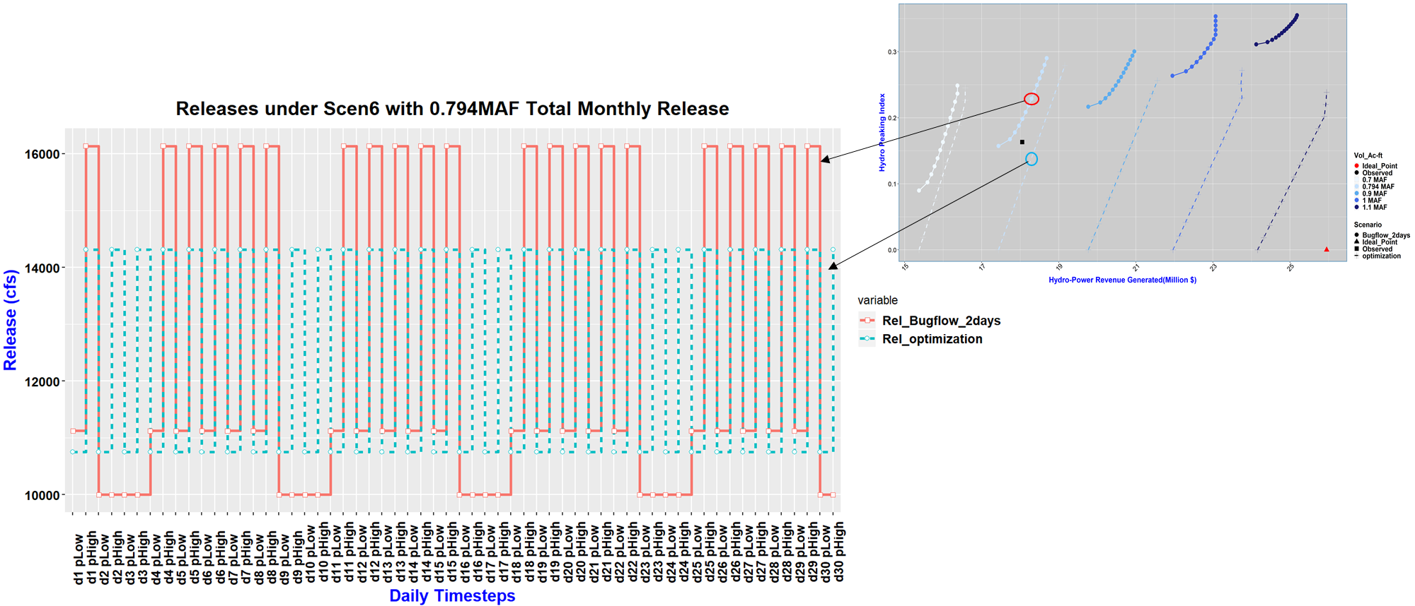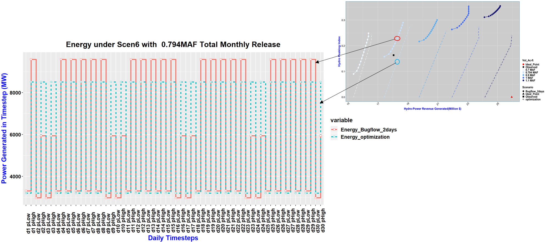

**Figure 7** **On the right top is the tradeoff curve with 10000 cfs steady Bug flow release. Whereas, on the left is hydrograph simulated for two scenarios (Optimization and 2-days Bug flow) for lower extreme point of both scenarios. which curve (total monthly volume value) and points we are looking on.**

**Figure 8 On the right top is the tradeoff curve with 10000 cfs steady Bugflow release. Whereas, on the left is Energy generated for two scenarios (Optimization and 2-days Bugflow) for lower extreme point of both scenarios. Arrows are guiding which curve (total monthly volume value) and points we are looking.**

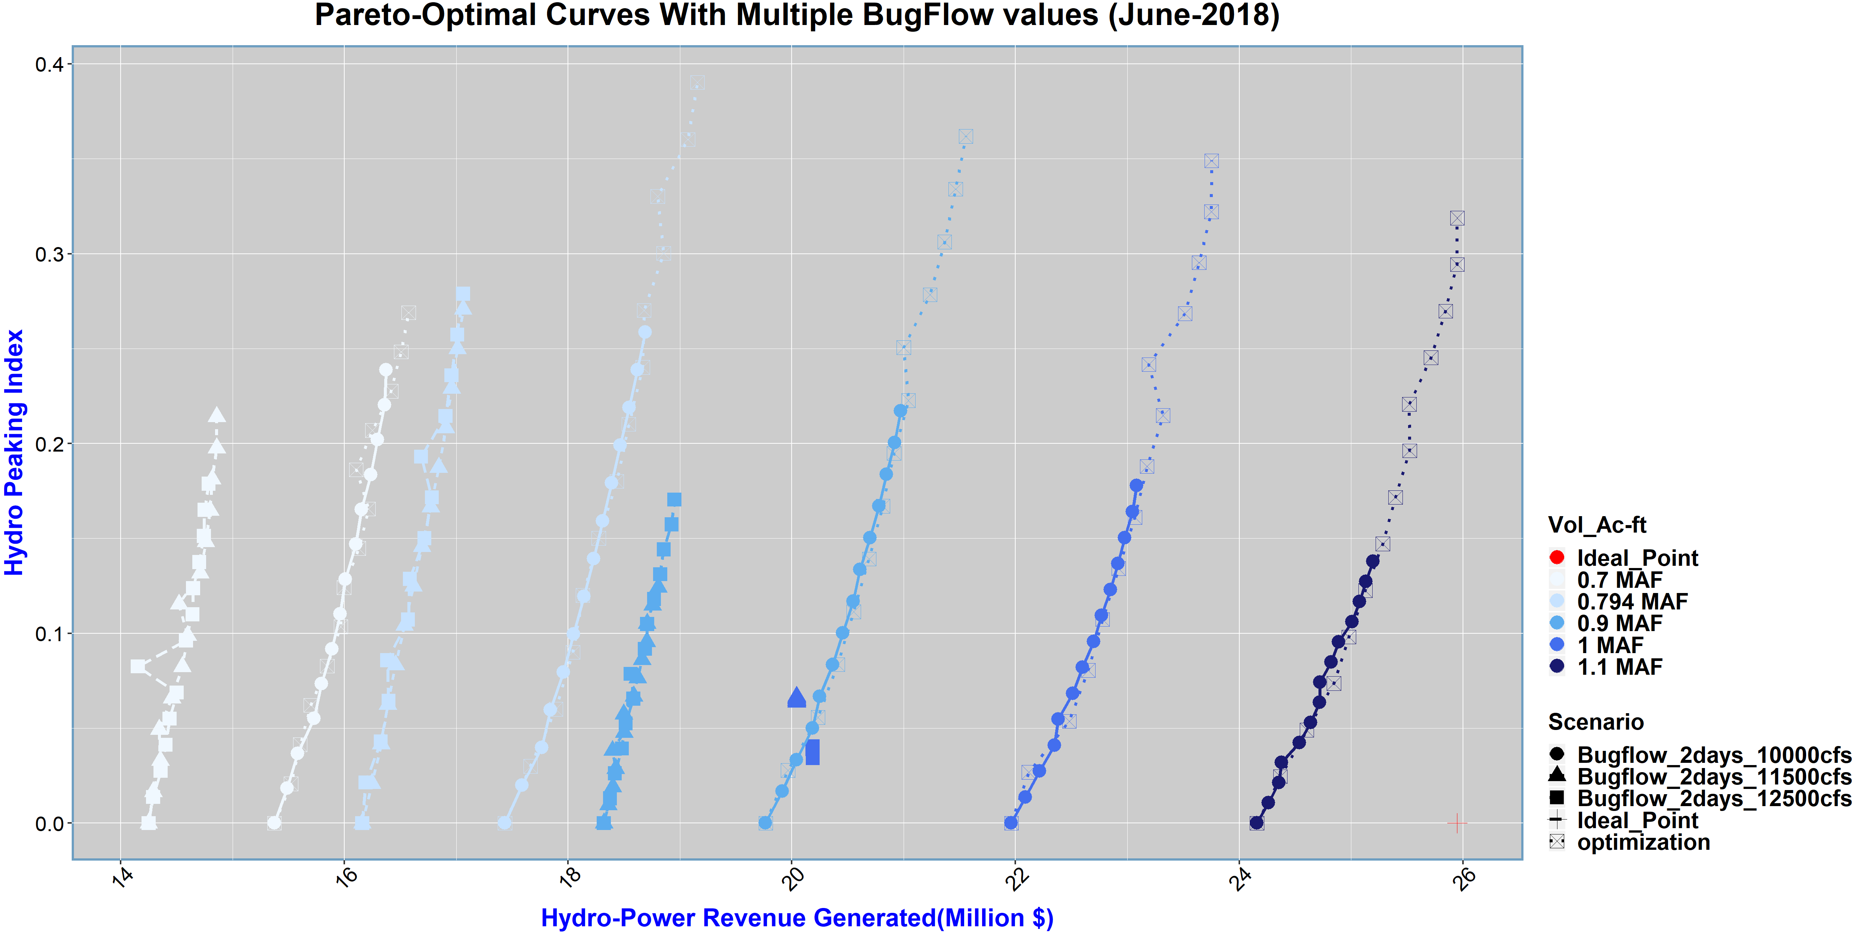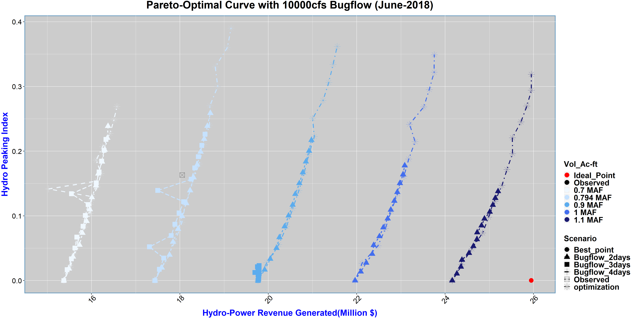

**Figure 9** **Trade-off curves for different total monthly volumes under different number of bug flow days scenarios. In case of 1 and 1.1 MAF volume, the 3 and 4 days bug flow runs were infeasible, hence, ignored. While, for 0.9 MAF volume the 4 days Bugflow run was infeasible and ignored. In case of 0.7 and 0.794 MAF volume runs, the model solution was found only feasible instead of optimal. Hence, those points were bit off the curve and can be witnessed in the figure.**

**CONCLUSION**

**Figure 11** **Trade-off curves for different total monthly volumes under different Bugflow release value scenarios.**

The objective of the study was to develop an optimization model that can show the trade-off between hydropeaking index and hydro-power revenue generation.

The model was initially tested with both the monthly averaged CV and daily CV averaged over the month approaches. The results from the monthly averaged CV approach (Figure 6) shows a significant window of opportunity to improve both the objectives by adopting the suggested optimized release pattern instead of following 2 days Bugflow practice (stable flows on weekends).

On the contrary, the results from the daily CV averaged over the month approach (Figure 7) doesn’t show any window between optimization and 2 days Bugflow scenario. However, the major takeaway from Figure 7 is that the difference in revenue generated between the observed point and the min point on the curve -having zero hydropeaking index- is almost insignificant (half a million $ only). Overall, the results from both approaches concludes that by increasing the total release volume the model simultaneously generates more revenue and reduces the hydropeaking index value (win-win trade-off).

In addition, the results from the runs with increased Bugflow days doesn’t show any significant difference as the curves are either overlapping or the solution becomes infeasible (Figure 10). However, the results from the runs with increased Bugflow release value show a significant decrease in hydropower revenue generation objective (Figure 11). Hence, the increase in Bugflow release value can be a serious concern for hydropower sector.

challenge the idea that hydropeaking index is a suitable metric to quantify bugs suitability. Hence, further research is required to define a better bug suitability metric.

updated model along with results will be publicly available in near future at: <https://github.com/moazzamalirind/-Bug-flow->

**ACKNOWLEDGEMENT**

This work is funded by center for Colorado River studies, Utah State university under the future of the Colorado River project. In addition, we are thankful to the staff of GCMRC and WAPA; especially Clayton Palmer (WAPA), Craig Ellsworth (WAPA), and Charles Yackulic (GCMRC) for their continuous support and suggestions.

**REFRENCES**

Acreman, M., Arthington, A.H., Colloff, M.J., Couch, C., Crossman, N.D., Dyer, F., Overton, I., Pollino, C.A., Stewardson, M.J., Young,W., 2014. Environmental flows for natural, hybrid, and novel riverine ecosystems in a changing world. Front. Ecol. Environ. 12, 466-473.

Adams, L. E., J. R. Lund, P. B. Moyle, R. M. Quinones, J. D. Herman, and T. A. O’Rear (2017), Environmental hedging: A theory and method for

reconciling reservoir operations for downstream ecology and water supply, Water Resour. Res., 53, 7816– 7831

Alafifi, Ayman H., and David E. Rosenberg. 2016. "Systems Modeling to Improve River, Riparian, and Wetland Habitat Quality and." River Research and Applications 22.5: 503-523.

Arthington, A., 2012. Environmental Flows - Saving Rivers in the Third Millennium. University of California Press.

Baxter CV, Fausch KD, Saunders WC. 2005. Tangled webs: Reciprocal flows of invertebrate prey link streams and riparian zones. Freshwater Biology 50: 201–220.

Carpenter SR, Stanley EH, Zanden MJV. 2011. State of the world’s freshwater ecosystems: Physical, chemical, and biological changes. Annual Review of the Environment and Resources 36: 75–99.

Førsund FR. 2015. Hydropower Economics. Springer

[GCDAMP] Glen Canyon Dam adaptive monitoring program. 2019. Glen Canyon. GCDAMP. (21 December 2019; <http://gcdamp.com/index.php?title=The_Bugflow_Experiment>)

Hart, B.T., 2015. The Australian Murray Darling Basin Plan: challenges in its implementation (part 1). Int. J. Water Resour. Dev. 1-16.

Harman, C., Stewardson, M., 2005. Optimizing dam release rules to meet environmental flow targets. River Res. Appl. 21, 113-129.

Kennedy, Theodore A., et al., 2016. "Flow management for hydropower extirpates aquatic insects, undermining river food webs." BioScience 66.7: 561-575.

Merritt RW, Cummins KW, Berg MB, eds. 2008. An Introduction To The Aquatic Insects Of North America. Kendall Hunt.

Moog O. 1993. Quantification of daily peak hydropower effects on aquatic fauna and management to minimize environmental impacts. Regulated Rivers: Research and Management 8: 5–14.

Nakano S, and Murakami M. 2001. Reciprocal subsidies: Dynamic interdependence between terrestrial and aquatic food webs. Proceedings of the National Academy of Sciences 98: 166–170.

National park services., 2011-2012. <https://www.nps.gov/grca/learn/education/upload/EcoArticle-Dec2011-12.pdf>

Nilsson C, Reidy CA, Dynesius M, Revenga C. 2005. Fragmentation and flow regulation of the world’s large river systems. Science 308: 405–408.

Null, S. E., & Lund, J. R., 2012. Fish habitat optimization to prioritize river restoration decisions. River research and applications, 28(9), 1378-1393.

Olden JD, Naiman RJ. 2010. Incorporating thermal regimes into environmental flows assessments: Modifying dam operations to restore freshwater ecosystem integrity. Freshwater Biology 55: 86–107.

Pegram, G., Li, Y., Le Quesne, T., Speed, J., Li, J., Shen, F., 2013. River Basin Planning: Principles. Procedures and Approaches for Strategic Planning. UNESCO, Paris.

Ploussard, Q., & Veselka, T. D. (2019). Financial Analysis of the 2018 Glen Canyon Dam Bug Flow Experiment (No. ANL-19/19). Argonne National Lab. (ANL), Argonne, IL (United States).

Poff NL, Olden JD, Merritt DM, Pepin DM. 2007. Homogenization of regional river dynamics by dams and global biodiversity implications. Proceedings of the National Academy of Sciences 104: 5732–5737.

Poff, N. L., Brown, C. M., Grantham, T. E., Matthews, J. H., Palmer, M. A., Spence, C. M., ... & Baeza, A. 2016. Sustainable water management under future uncertainty with eco-engineering decision scaling. Nature Climate Change, 6(1), 25-34.

Richter, B.D., 2014. Chasing Water: a Guide for Moving from Scarcity to Sustainability. Island press, Washington.

Schmidt JC, Wilcock PR. 2008. Metrics for assessing the downstream effects of dams. Water Resources Research 44: 1–19.

Statzner B, Beche LA. 2010. Can biological invertebrate traits resolve effects of multiple stressors on running water ecosystems? Freshwater Biology 55: 80–119.

Stevens LE, Shannon JP, Blinn DW. 1997. Colorado River benthic ecology in Grand Canyon, Arizona, USA: Dam, tributary, and geomorphological influences. Regulated Rivers: Research and Management 13: 129–149.

Tharme, R.E., 2003. A global perspective on environmental flow assessment: emerging trends in the development and application of environmental flow methodologies for rivers. River Res. Appl. 19, 397-441.

Topping DJ, Schmidt JC, Vierra LE. 2003. Computation and analysis of the instantaneous-discharge record for the Colorado River at Lees Ferry, Arizona: May 8, 1921, through September 30, 2000. US Geological Survey (USGS). USGS Professional Paper no. 1677

[USBR] US Department of the Interior Bureau of Reclamation. 2016. Glen Canyon Dam Long-Term Experimental and Management Plan Environmental Impact Statement. USBR. (11 April 2016; http://ltempeis.anl.gov/documents/draft-eis)

[USBR] US Department of the Interior Bureau of Reclamation. 2019. Glen Canyon Unit. USBR. (21 December 2019; <https://www.usbr.gov/uc/rm/crsp/gc/>)

World Commission on Dams. 2000. Dams and Development: A New Framework for Decision-Making. Earthscan.